

Bejamin Jo

Full-Stack Developer

 Montreal, Japan  +1 (213) 985 0522

 top.developer221@gmail.com Top0221

 sunshine221#8822 +1 (213) 985 0522

Experienced Web Developer who is adept in all stages of advanced web development.  
Knowledgeable in a user interface, testing, and debugging processes. Bringing forth expertise in the design, installation, testing, and maintenance of web systems. Equipped with an adverse and promising skill-set. Proficient in an assortment of technologies, including PHP, JavaScript, Node, TypeScript, React, Vue, Laravel, Python, Java, JSP, HTML/CSS, MySQL, Oracle, MongoDB, and Microsoft SQL Server. Able to effectively self-manage during independent projects, as well as collaborate in a team setting.

Projects



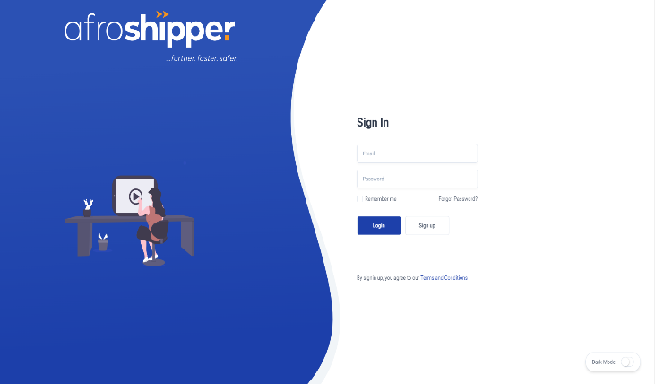

# Laravel + Vue + MySQL

This is a shipping platform, which provides shipping invoices.

<https://www.app.afroshipper.com>

# 

# React + Laravel + AWS

Atelier.M is an artisanal workshop dedicated to the creation and construction of unique and custom-made Metalwork and Locksmithing.

<https://www.atelier-metal.com>

# 

# NextJS + NodeJS + AWS

This platform is a service website that serves the new shampoo, and how to use and  
refill the club, the advantages, and disadvantages of hair management.

[https://www.hairstory.com](http://www.hairstory.com)

# React + Express + TailwindCSS

Mishmash was built on a deep passion for everything office.

https://www.mishmash.pt

# 

# React + Express + Payment Integration

Nobull is a Multi-purpose Fitness service. There are many services for Sportsmen  
and women such as E-Shop, global store network, training guide, refer a friend,  
Nobull tv, Nobull digital gift card, etc.

<https://www.nobullproject.com>

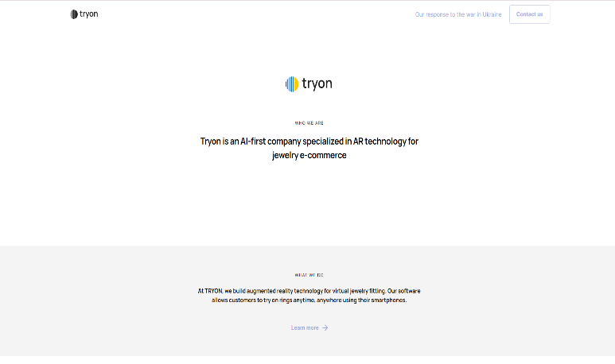

# Angular + Zone.js + BootStrap

This is a platform that provides Augmented Reality(AR) for Jewelry. As we know, jewelry is the best concern for women, so they want to see the beautiful jewelry ring with their fingers.

https://tryon.jewelry

# Laravel + Livewire + MySQL + Mongo

Rouillard is a website that serves a lot of modern and comfortable furniture for workspaces and offices.

<https://rouillard.ca>

# 

# Angular + Laravel + MySQL + SCSS

Saints & Stars is the only premium boutique gym where everything is focused on  
creating a perfect flow to achieve the next level of fitness and be part of a  
like-minded community of highly ambitious people.

<https://www.saints-stars.com>

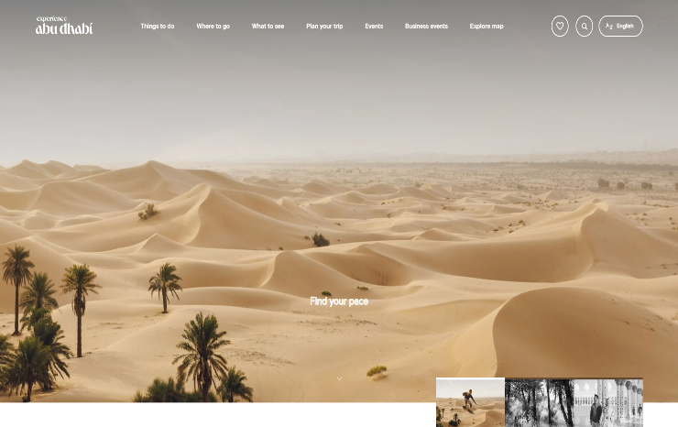

# ASP.NET + React + MSSQL

This is a travel Abu Dhabi platform, which provides the introduction of famous  
areas, cultures, things, events, shopping, nature, adventure, arts and lifestyle, and business, etc.

<https://visitabudhabi.ae>



# Gatsby + React + Bootstrap + SCSS

TSI runs the products and stores full of originality while demonstrating its individuality by group companies that have many diverse brands such as EC business, sales agency business, restaurant business and so on.

<https://www.tsi-holdings.com/freshers>

# Skills

# ● Project Estimations, Requirements Gathering, UI/Function Improvement, ● Code Versioning/Debugging, Flexible Adaptable, Cultural Awareness, ● Project Management, Solutions Deployment, Web Security, ● Database Design/Programming, SQL Integration ● Frontend/Backend Development, Website Optimization, ● JavaScript, Node, Express, React, Vue, TypeScript, ● PHP, Laravel, Symfony, CodeIgniter, ● Python, Django, Flask, ● HTML/HTML5, CSS/CSS3/SCSS, Bootstrap, Vuetify, Material, Tailwind, ● MySQL, PostgreSQL, MS-SQL, MongoDB, SQLite, ● Java, JSP, Spring, Spring-MVC, Spring Boot, Struts, Hibernate, ● Blockchain, Solidity, NFT, Web3.js, ● AWS, EC2, Lambda, S3, Azure, Cloudways, CPanel, FastPanel

# Work Experience



## Software Engineer - Remote



### 1ST NATIONS MORTGAGE CORPORATION

## Apr 2019 - Nov 2022 (3 year 8 months)

### - Developing 20+ WebApps using HTML5, CSS, JavaScript, Tailwind CSS, React.js, Node.js, and Web3. - Participated in 3 Marketplace Development, and played an important role in development - Developed DApps using React / Redux / Redux-Saga / React Hooks / Web3 - Web Hosting to AWS / CPanel. Used ASP.NET Core and Python Flask and Java. - Used GraphQL and REST API - Development of Electron App and Used Next.js and - Nuxt.js – Web Hosting to AWS / Azure - Cloud Systems

 Full-Stack Engineer – Remote

### TourMega

Apr 2016 - Feb 2019

## - Developed automated software which manages infrastructure without human intervention. - Built multiple language website using Laravel with Vue.js frontend developer. - Built shopping website using Django with React. - Implemented SEO(Search Engine Optimization) for several websites. - Paypal integration using Laravel and Node.js. - Web Scrapping using Python. - Web Hosting to Azure / CWP

 Full-Stack Developer - Remote

### EKOHE

Feb 2014 - Apr 2015

## - Implemented Single Page Application architecture and client side MVC using React - Used Bootstrap features such as Model objects, Tabs, Tooltips, Carousals throughout the application - Used Angular UI Grid directives such as filters, rootscope, childscope, modal, and template, etc. - Implemented components and wire-frames using cross-browser compatible CSS, JavaScript, jQuery and Ajax, Angular JS. - Used ng-view directive to refresh only certain section of the page and reduce the load on the web server. - Implemented websites using Laravel Blade and Bootstrap and JavaScript and CSS

# Education



## The Education of University in Hong Kong, Bachelor’s degree

### Computer / Information Technology 5 years graduation. 2010-2014

Graduation Thesis:

“Study on Distortion Correction of Camera Image and Projection Image in

Multi-Projection System”

## Tokyo Institute of Technology

### Computer / IT Engineering 2 years graduation. 2015-2016

Graduation Thesis:

“Detection of the point of impact in the target by point to point”

# Training Courses



* JavaScript Web Projects: 20 Projects to Build Your PortfolioUdemy - 2017  
  ● 20 projects with pure JavaScript, HTML5, CSS3 with all code provided  
  ● Go from a total expert to a confident JavaScript developer.  
  ● Learned UI/UX practices to build responsive and mobile-first web applications
* React-The Complete Guide(incl Hooks, React, Router, Redux)Udemy - 2018  
  ● Learned to build powerful, fast, user-friendly, and reactive web apps.  
  ● Learned all about React Hooks and React Components.
* NodeJS-The Complete Guide(MVC, REST APIs, GraphQL, Deno)  
  Udemy - 2018  
  ● Worked with one of the most in-demand web development programming languages.  
  ● Build modern, fast, and scalable server-side web applications with NodeJS, databases like SQL or MongoDB, and more.  
  ● Learned the basics as well as advanced concepts of NodeJS in great detail.  
  ● Understood the NodeJS ecosystem and build server-side rendered apps, REST APIs, and GraphQl APIs
* Python for Beginners: Learn Python Programming(Python 3)Udemy - 2019  
  ● Wrote Python programs that can be used on Linux, Mac, and Unix operating  
  systems